Cinnamon Oatmeal Muffins

Ingredients

Muffin Mix:
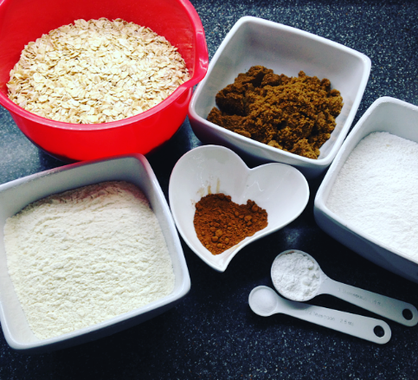
450g - Rolled Oats
150g – Plain Flour
250ml – Milk
2 - Eggs
150g – Brown Sugar
115g – Butter
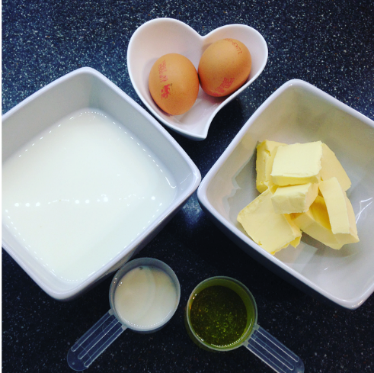
60ml – Vegetable Oil
1 tbsp – Cinnamon

Topping:
150g – Icing Sugar
2 tbsp – Milk

Why not add that little extra..?
- Raisins/Dates
- Chocolate Chips
- Fudge Pieces
- Chopped Bananas

What to do!

Preheat your oven to 180c & line your muffin tin with some pretty muffin cases!

- In a large Bowl you’ll need to combine your rolled oats, flour, salt, baking powder & cinnamon. In a separate bowl, whisk together the two eggs.

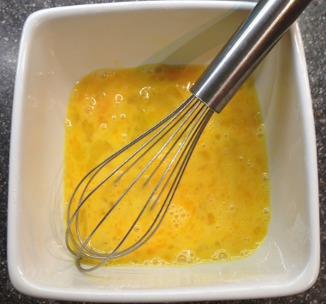
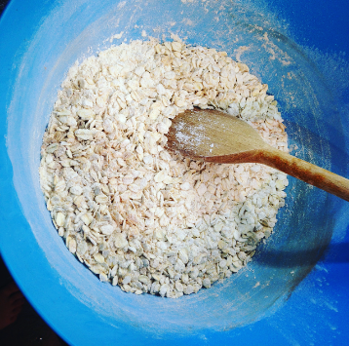

- In a third bowl, melt the butter and then mix together with your sugar. Once they’re well combine, add this mixture, along with the whisked eggs into the oatmeal mixture and stir until fully blended.
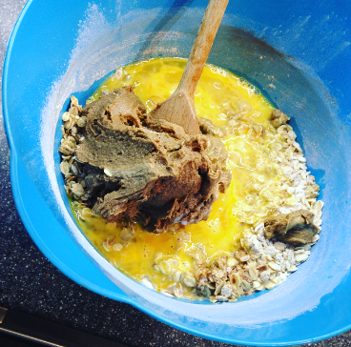
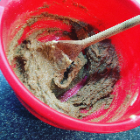

- Once your mixture if fully combine, evenly scoop your mixture into your muffin cases (I measure out two tablespoons worth with my measuring spoons, or you could use an ice cream scoop to help you get an event amount in your cases!)
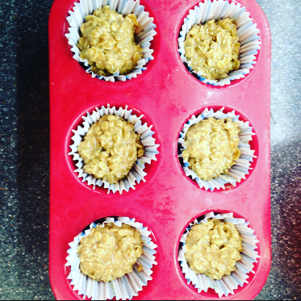
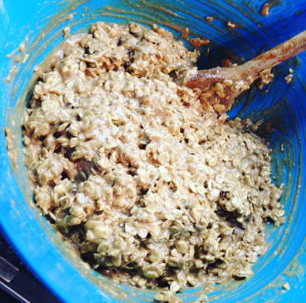

- Place your muffins in the oven for 15-18 minutes, they should be golden brown on top but check with a knife/cake tester to make sure they’re fully cooked in the middle. Once cooked, leave them on the cooling rack for 5 minutes and make simple but very yummy icing!
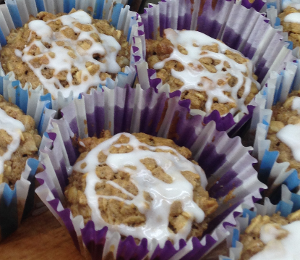
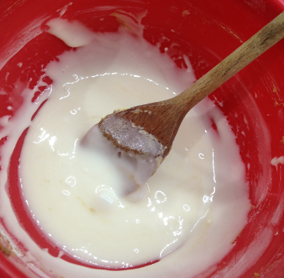
- Pour your milk into the icing sugar and stir well, you might have to add additional milk to make the mixture a little smoother – but be careful not to add too much!! Double check your muffins have completely cooled, and drizzle your icing on top.

- Then... ENJOY!
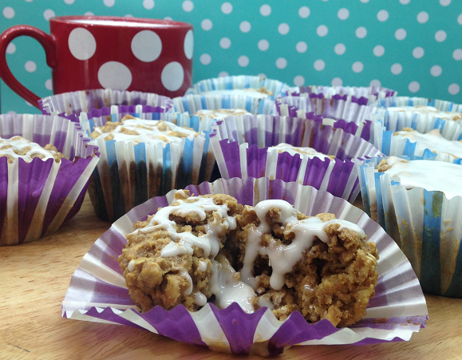

♥
Thank you for reading!
♥ ♥ ♥
Please give me your feedback either by visiting our website or email us:
www.capalscupcakes.weebly.com
or
capalscupcakes@gmail.com

